|  |  |  |  |  |
| --- | --- | --- | --- | --- |
|  |  | | | |
|  | |  | | |
| Project: | | Personal Tutoring Service (PTS) | | |
| Team No.: | | Team 002 | | |
| Class: | | CSE 3310; Fall 2013 | | |
| Module: | | System Requirements Analysis (SRA) | | |
| Deliverable: | | SRA Document | | |
| Version: | | [1.5] | Date: | [12/5/2013] |

Contributors:

Dineth Hettiarachchi

Samir Shrestha

Roshan Lamichane

Santosh Shrestha

Revision History

| Version number | Date | Originator | Reason for change | High level description of changes |
| --- | --- | --- | --- | --- |
| 1.0 | 09/18/2013 | Dineth, Samir, Roshan, Santosh | Initial draft | Added content for the following sections: Objectives, System Requirements, Context Diagram, UMLs |
| 1.1 | 10/10/2013 | Dineth, Samir, Roshan, Santosh | Updated existing content | Updated the business objectives, system requirements and hardware infrastructure |
| 1.2 | 10/12/20013 | Dineth, Samir, Roshan, Santosh | Added new content | Added conceptual database model and screenshots of the template |
| 1.3 | 10/15/2013 | Dineth, Samir, Roshan, Santosh | Added new content/reviewed existing content | Added a screenshot |
| 1.4 | 10/16/2013 | Dineth, Samir, Roshan, Santosh | Updated existing content | Made minor changes to the UML diagram for Login |
| 1.5 | 11/30/2013 | Dineth, Samir, Roshan, Santosh | Added new content | Added UML diagram for search which was not there in version 1.4 |

TABLE OF CONTENTS

1. Introduction and Project Overview 3

2. Objectives 4

2.1 BUSINESS Objectives 4

2.2 SYSTEM Objectives 7

3. Project Context Diagram 8

4. Systems Requirements 9

4.1 Requirements Overview 9

4.2 “Registration” Requirements 10

4.3 “Login and Security” Requirements 12

4.4 “Setup Tutoring Categories” Requirements 13

4.5 “Tutoring Service Offering” Requirements 14

4.6 “Search” Requirements 15

4.7 “Commissions and Payments” Requirements 17

4.8 “Advertisements” Requirements 18

4.9 “Review a Tutor” Requirements 19

4.10 “Communication” Requirements 20

4.11 “Map” Requirements 22

5. Software Processes and Infrastructure 24

5.1 Hardware and Infrastructure 24

5.2 UML Diagrams 25

5.3 Conceptual Data Model - Database 34

5.4 Screenshots 35

5.5 Test Plan 36

6. Assumptions and Constraints 37

6.1 ASSUMPTIONS 37

6.2 CONSTRAINTS 37

6.3 Out of Scope material 37

7. Delivery and Schedule 38

8. Stakeholder Approval Form 39

Appendix: 40

# 1. Introduction and Project Overview

The overall objective of the project is to design and implement a web-based system, which helps individuals to find a tutoring service and to help tutors to offer their services. The system will allow parents or students who are in need of a tutor to search for a tutor based on their needs. And the system will allow tutors to maintain a tutor profile through the website and they can advertise their profile for a nominal fee.

Regular visitors who are in search for a tutor don’t necessarily have to register on the website in order to browse for a tutor. However, they need to register to contact a particular tutor. Also, registered users have the ability to review tutors which will enhance the quality of the website and the user experience.

Tutors can choose to display their advertisements for the period of amount they desire or they can opt in for a subscription-based fee. In addition to that, tutors can choose to pay an additional amount which will make them featured members, allowing their advertisements to receive priority, when other users searching for a tutor.

The system will allow users to connect their social network accounts such as Facebook or Google+, allowing the system to recommend tutors based on which tutors have been chosen by users’ friends or the network. To further enhance the browsing experience, we will incorporate an interactive map with the locations of both tutors and users. To make the interaction between the tutor and the user more secure, it is recommend to use the built-in messaging system and not to share personal contact details before they get to know each other.

The user interface will be optimized for most of the devices and browsers commonly used, and the interface will be user-friendly to anyone with a basic experience in web browsing and English language.

The goal of the project is to help both students/parents and tutors to find or offer tutoring services as well as to make it a profitable business for the company. Therefore, user experience and the user interface will be optimized meet the above expectations.

# 2. Objectives

## 2.1 BUSINESS Objectives

The following is a list of business objectives:

**Objective 1:** Registration: Users must register by providing the following information:

* Name [last name, middle name {optional}, first name]
* Phone numbers [primary phone, secondary phone]
* E-mail address
* Physical address [street name, apt # {optional}, city, state, country]
* Date of birth
* Gender
* Username
* Password

**Objective 2**: Login: Non-visitors must login to the system by providing the following   
 information:

* Username
* Password

**Objective 3**: Tutor Profile: Tutors must complete their profiles by providing the following  
 information; and it is required in order to proceed with make their profile   
 public/advertise:

* Avatar
* Nickname
* Tag line
* Bio
* Education credentials [high school, college education {optional}, certifications {optional}]
* Experience
* Subjects
* Hourly rate
* Languages spoken
* Transportation availability
* Availability schedule

**Objective 4**: Search: Users must be able to search for a tutor based on the following criteria:

* Zip Code
* Subject
* Tutor name

**Objective 5**: Search: Users must be able to further filter the search through the following   
 criteria:

* Distance
* Rating
* Hourly rate

**Objective 6**: Tutoring Categories: Administrators must be able to create a new tutoring  
 category upon requested by providing the following information:

* Parent category {optional}
* Category name

**Objective 7**: Payments: Tutors must provide the following information in order to proceed with a payment:

* Credit card type
* Credit card number
* Credit card CSV number
* Credit card expiration date
* Billing address {optional, if differ from the physical address}

**Objective 8**: Advertisement: 3rd party companies and organizations can request to display  
 sponsored advertisements if they adhere to the following rules:

* The advertisements must be related to the website niche; however, it should not be in the same niche
* A person/company/organization can display only one advertisement per page
* Homepage should not display any ads; there should be no more than 3 advertisements per page

**Objective 9**: Revenue: The revenue will be collected through the following sources:

* Tutor membership fees
* Sponsor advertisements

**Objective 10**: Communication: Students/parents and tutors can communicate using the  
 following methods:

* Via verified email addresses
* Via the inbuilt messaging system

**Objective 11**: Map: Users should be able to view a map of where the tutor is located along  
 with the following information:

* Location of the tutor
* Maximum travel radius
* Option to get the directions from the current location or user’s physical location to tutors provided location

**Objective 12**: Social Integration: Users must be able to integrate their social network   
 accounts in order to see recommendations for tutors by friends or to find out   
 the popular tutors in the area. The following social networks must be supported   
 initially.

* Facebook
* Google+
* Twitter

**Objective 13**: Marketing: The system will utilize the following methods of paid marketing and   
 peer marketing.

* Google AdWords
* Social Networks [Facebook/Google+/Twitter]

## 2.2 SYSTEM Objectives

The following is a list of system objectives:

**Objective 1**: System will be Web-based.

**Objective 2**: System will be run on an Apache Server.

**Objective 3**: System will use PHP as the server-side scripting language.

**Objective 4**: System will use JavaScript as the client-side programming language; however,   
 will only be used where a particular function cannot be replaced by the  
 server-side language [for added security purposes].

**Objective 5**: MySQL will be used as the database management system.

**Objective 6**: Webpages will be optimized using the latest versions of HTML (HTML5) and  
 CSS (CSS3).

**Objective 7**: System will use AJAX to prevent the need of having to refresh the page   
 frequently; however, PHP will take priority as a fallback if JavaScript is  
 disable on the user’s browser.

**Objective 8**: System will utilize Modernizr JavaScript Library to detect browser compatibility;  
 hence, then will use fallback functions.

**Objective 9**: System will utilize Boothstrap [JavaScript and CSS framework] to create a   
 responsive design [i.e. touch-input friendly, multiple-resolution support].

**Objective 10:** WAI-ARIA roles will be added in order to optimize for the screen readers.

**Objective 11:** HTML Microdata and rich-snippets will be used for a better Search Engine   
 Optimization.

**Objective 12:** System will not be optimized for Microsoft Internet Explorer versions 8 or   
 below.

**Objective 13:** System UI colors between the text and the background should have a   
 minimum contrast of 4.0.

# 3. Project Context Diagram

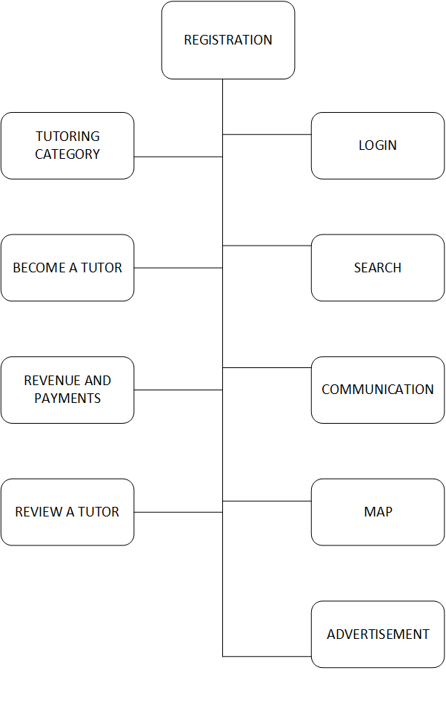

# 4. Systems Requirements

## 4.1 Requirements Overview

A new user who is entered the website for the first time has two options: to either search for a tutor or to become a tutor on the website. However, the homepage will give more priority towards the users who want to find a tutor.

Initially, a user can search for a tutor by entering their location information or by entering the desired subject into the static search bar which will be displayed throughout all the web pages on the system. Optionally, they can refine their search query by choosing refine parameters such as distance, transportation availability etc. on the search pane. Then they are able to view the tutor profile by selecting a tutor from the results list. If they want to contact the desired tutor, they require to register for an account on the website to proceed. Once the users have received service from a particular tutor, they can rate or write a review on the tutor using the web app.

Tutors can utilize the website to promote their service. They must pay a nominal fee/enroll in a subscription to display an advertisement of their tutor profile via the website. They must have the ability to take down the advertisement or to set the tutor profile to private at any time. However, they will not receive any sort of refund. After a particular tutor profile advertisement is expired, they should have the ability to renew the tutor advertisement or to extend the period they needed to display the advertisement.

Both users must start a conversation via the built-in messaging system. However, it is up to them to continue through the website’s messaging system or to use email or phone as the mean of communication.

Tutors must provide with their physical address as it will be used to display a map along with other information on the tutor profile page. The website must be able to get directions and other information between the user’s address and the tutor’s location using the Google Maps API.

The website will display up to 3 sponsored advertisements per page except on the homepage. Sponsors must make a request via the contact page, if they wish to display a sponsor advertisement on the website. However, only the administrator of the website can make the decision upon reviewing their request.

## 4.2 “Registration” Requirements

|  |  |
| --- | --- |
| **Requirement Title:**  (*required) | Registration |
| **Sequence No:**  (*required) | 001 |
| **Short description:**  (*required) | Register a new student/parent user |
| **Detailed Description:**  (*required) | Obtain the following information from the users who satisfy the following conditions.  First Name: Must be the legal first name as mentioned in   user’s driver’s license.  Last Name: Must be the legal last name as mentioned in   user’s driver’s license  Email: Must be a valid email address  DOB: Must be valid and entered in the following   format mm/dd/yyyy  Address: Must include Street Name and Block  Number/Apt #, City, State, Zip Code, Country  Username: Any alpha numeric characters between 4-10   characters long  Password: Must be at least 6 characters long, at most 16  Must include at least 1 numerical character  Must include at least 1 Uppercase character  Re-enter Password: Password must be re-entered to   avoid potential error.  Submit: To proceed with establishing username/password  Cancel: To cancel the registration process |
| **Pre-Conditions**:  (optional) | * User is a student or a parent who is looking for a tutor User hasn’t already registered * User must be 18 yrs./older * User is not visually impaired * User must understand English language |
| **Post Conditions:**  (optional) | * Inform user via email that the new account has been setup * Inform user via email that new username and password has been setup, also explain user the procedure to login. |
| **Other attributes:**  (optional) | * Avoid duplicate usernames * Avoid duplicate email addresses * Users should be able to sign up using the social network credentials [Facebook, Googe+ etc] |

|  |  |
| --- | --- |
| **Requirement Title:**  **(*required)** | Registration |
| **Sequence No:**  **(*required)** | 002 |
| **Short description:**  **(*required)** | Register a New Tutor. |
| **Detailed Description:**  **(*required)** | Obtain the following information from the Tutor who satisfies the following conditions. First Name: Must be legal first name as mentioned in  user’s driver’s license.  Last Name: Must be legal last name as mentioned in   user’s driver’s license  Email: Must be a valid email address  DOB: Must be valid and entered in the format  (mm/dd/yyyy)  Address: Must include Street Name and Block No/  Apt No, City, State, Zip Code, Country  Username: Any alpha numeric characters between 4-10   characters long  Password: Must be at least 6 characters long, at most 16  Must include at least 1 numerical character  Must include at least 1 Uppercase character  Re-enter Password: Password must be re-entered to   avoid potential error.  Submit: To proceed with the established   username/password  Cancel: To cancel the registration process |
| **Pre-Conditions:**  **(optional)** | * Tutor hasn’t registered yet * Tutor must be 18 yrs./older and hold a valid credit/debit card * Tutor must have proof of academic qualifications. * Tutor must be proficient in spoken and written English. |
| **Post Conditions:**  **(optional)** | * Inform tutor via email that the new account has been setup * Inform user via email that new username and password has been setup, also explain user the procedure to login. * Inform user via email to complete the tutor profile |
| **Other attributes:**  **(optional)** | * Avoid duplicate tutor id’s (usernames) * Avoid duplicate tutor email addresses * Limit the system access to only browsing until the tutor profile is completed and payment has been made. |

## 4.3 “Login and Security” Requirements

|  |  |
| --- | --- |
| **Requirement Title:**  (*required) | Login |
| **Sequence No:**  (*required) | 001 |
| **Short description:**  (*required) | Existing user logs in. |
| **Detailed Description:**  (*required) | * User must provide previously established username/password to login * If username/password combination is invalid, allow for 4 retries * After the 4th try, block the user IP address for 5 minutes and notify via email about potential unauthorized access |
| **Pre-Conditions**:  (optional) | User must already have a username/password established /see Registration requirements Seq No: 001 |
| **Post Conditions:**  (optional) | Notify via email to reset the password upon unsuccessful |
| **Other attributes:**  (optional) | Keep log of login attempts in the backend system  Users who have not logged in for the past 7 days will be automatically logged out and will have to login again.  Passwords will be saved using SHA512 encryption. |

|  |  |
| --- | --- |
| **Requirement Title:**  (*required) | Login |
| **Sequence No:**  (*required) | 002 |
| **Short description:**  (*required) | Reset user password |
| **Detailed Description:**  (*required) | * User must provide the following information in order to proceed with resetting the password:   + Username, Date of Birth * Upon confirming the username and DOB, system must send an email to the email address which was provided during the user registration along with a link to reset the password, and a temporary password * Select new Password:   + User must enter the temporary password mentioned in the email   + User must select a new password. See/ Registration Seq: 001 for password requirements. |
| **Pre-Conditions**:  (optional) | User must know his username. |
| **Post Conditions:**  (optional) | Notify user regarding the password change via email |
| **Other attributes:**  (optional) | * Keep log of password reset history. * Do not allow more than 1 password reset in 1 week. |

## 4.4 “Setup Tutoring Categories” Requirements

|  |  |
| --- | --- |
| **Requirement Title:**  (*required) | Setup Category |
| **Sequence No:**  (*required) | 001 |
| **Short description:**  (*required) | Setup Tutoring Categories |
| **Detailed Description:**  (*required) | Select following details for a Category.  Category Name: Must not be longer than 10 characters.   Cannot include any numbers.   Must reflect a valid subject that can be   found in Wikipedia.  Tutor List: Each category should have at least one if   not more Tutors.   The list should include Tutor ID and the   date he/she registered  Tutor Count: A list of total tutor count within a   category must be maintain within   the database.  Initially 5 categories will be setup:  The categories are: 1. Math  2. Physics  3. Chemistry  4. Biology  5. Computer Science  Policy for adding a new category:  The new category can be created in the database only by the system admins. |
| **Pre-Conditions:** | * Each category initially setup has at least one tutor. * Tutor must be registered to be included in a category. |
| **Post Conditions:**  (optional) | * Notify all the tutors and students via email when a new category has been added by the system admin |
| **Other attributes:**  (optional) | * Users can request a new category via the website contact form. After validation and other necessary checks, the system admin may decide to add the new category. |

## 4.5 “Tutoring Service Offering” Requirements

|  |  |
| --- | --- |
| **Requirement Title:**  (*required) | Registration |
| **Sequence No:**  (*required) | 003 |
| **Short description:**  (*required) | Tutor Profile Setup |
| **Detailed Description:**  (*required) | Tutor Must provide the following details in order to complete the tutor profile.  Education: Tutor must provide education details as follows.  Degrees: All the education degrees tutor has  received.  Graduation Date: Respective date of all the   degrees achieved.  Institution name and location of all the institution  Tutor has been associated with  Category: Tutor must select a category from all the available  categories in the system. Can select multiple  categories.  Experience: Tutor must submit documented proof of any  experience related to previous tutoring  Travel Radius: Tutor must give the preferred distance in miles  that the tutor is willing to travel for tutoring.  Tutoring Rate: Tutor must specify a rate per hour.   It must not be greater than $100/hr  Membership: Tutor must select membership period in months.  Must select a minimum of 3 months.  Photo ID: Tutor must upload their image that clearly  identifies them.  Short Bio: Tutor must give a short bio describing their  interest, expertise and other qualifications in the  chosen tutoring category. Must be at least 50  words |
| **Pre-Conditions**:  (optional) | * Tutor must have at least a high school degree or equivalent. * Tutor photo ID must have been recently taken * Tutor must have a travel means |
| **Post Conditions:**  (optional) | * Notify tutor via email of profile setup completion. Allow tutor access to the system. |
| **Other attributes:**  (optional) | * Tutor can also mention their hobbies and other interests that is not directly related to the subject they want to tutor in. |

## 4.6 “Search” Requirements

|  |  |
| --- | --- |
| **Requirement Title:**  (*required) | Search |
| **Sequence No:**  (*required) | 001 |
| **Short description:**  (*required) | Search by distance |
| **Detailed Description:**  (*required) | -Users are able to search for the tutors according to their distance specifically through zip-code and city.  -Zip-code and city combination should match.  -Zip-code is 5 digit valid number that is greater than 10000 and less than or equal to 99999  If the search criteria doesn’t match, inform the user through the website. |
| **Pre-Conditions**:  (optional) |  |
| **Post Conditions:**  (optional) | After logging and searching, the user should be able to sign with the designated tutor. |
| **Other attributes:**  (optional) | User should enter the valid zip code and city match. |

|  |  |
| --- | --- |
| **Requirement Title:**  (*required) | Search |
| **Sequence No:**  (*required) | 002 |
| **Short description:**  (*required) | Displaying the information |
| **Detailed Description:**  (*required) | -When a user does the search through the search panel the website should display minimum of zero (if no tutor match is found) or maximum of 5 tutors.  -Display of more than 5 tutors matching the search criteria could be displayed by users’ preference in the website.  -Display should only show the users within 25 miles radius.  If there are no matches, notify the user in the window display. |
| **Pre-Conditions**:  (optional) | Tutors matching the criteria should be in the database. |
| **Post Conditions:**  (optional) | After displaying the tutors, the user should be able to select the desired tutor and sign up for the tutoring class. |
| **Other attributes:**  (optional) |  |

|  |  |
| --- | --- |
| **Requirement Title:**  (*required) | Search |
| **Sequence No:**  (*required) | 003 |
| **Short description:**  (*required) | Searching by the classification |
| **Detailed Description:**  (*required) | -User is able to search the tutors accordingly to the tutors’ classification.  -Classification as Math, Physics, Chemistry, Biology and Computer Science  If the user enters the invalid classification, notify the users. |
| **Pre-Conditions**:  (optional) | Classification should exist in database. |
| **Post Conditions:**  (optional) | After displaying the tutors, the user should be able to select the desired tutor and sign up for the tutoring class. |
| **Other attributes:**  (optional) | Classification can only be real world entity of subjects like Science or Mathematics. Imaginary subject classification should not be entered. |

|  |  |
| --- | --- |
| **Requirement Title:**  (*required) | Search |
| **Sequence No:**  (*required) | 004 |
| **Short description:**  (*required) | Searching by star rating |
| **Detailed Description:**  (*required) | -User is able to search the tutors by their rating which will be based on the stars (✰) given to the tutors by the previous students.  -The star-rating starts at 0 to 5 which goes with the increasing rating of betterment. |
| **Pre-Conditions**:  (optional) |  |
| **Post Conditions:**  (optional) | After displaying the tutors, the user should be able to select the desired tutor and sign up for the tutoring class. |
| **Other attributes:**  (optional) |  |

## 4.7 “Commissions and Payments” Requirements

|  |  |
| --- | --- |
| **Requirement Title:**  (*required) | Payment |
| **Sequence No:**  (*required) | 001 |
| **Short description:**  (*required) | Make a payment to the website |
| **Detailed Description:**  (*required) | User must provide detail information about the card:  First Name  Last Name  Billing address of the card  Card Number  Card expiration date  Card security code  Card type that can be used:  Visa  MasterCard  American Express  Discover |
| **Pre-Conditions**:  (optional) | * Must have a valid user Id. * Must have a valid credit/debit card. * Must have sufficient funds available. |
| **Post Conditions:**  (optional) | * Inform the user via email that the payment has been made and even provide the detailed information of the receipt. |
| **Other attributes:**  (optional) | * Users would be able signup for a subscription service. * Users would be able to store the information of the card for future use. |

## 4.8 “Advertisements” Requirements

|  |  |
| --- | --- |
| **Requirement Title:**  (*required) | Advertisement |
| **Sequence No:**  (*required) | 001 |
| **Short description:**  (*required) | Post an advertisement in the website. |
| **Detailed Description:**  (*required) | User must choose the appropriate ad unit:  300x250 Medium Rectangle  728x90 Leaderboard  160x600 Wide Skyscraper  320x50 Mobile Banner  User must provide type of advertisement:  Text Advertisements  Image Advertisements  User must provide the template of the advertisement:  If picture then user must send one or more pictures.  If text then user must provide enough text to display (no restriction)  User must provide the desired time period of the day to display   the ad:  Time period must be less than 24 hours.  User must read the advertisement policy and accept the terms before submitting the request. |
| **Pre-Conditions**:  (optional) | Must be valid tutor Id or valid Business (guest) Id.  Must satisfy the pre-condition of Payment Requirement. |
| **Post Conditions:**  (optional) | Inform the user via email about the ad-unit, type, time period and terms of contract of the advertisement that would be posted. |
| **Other attributes:**  (optional) | Users would be able to cancel the advertisement before the contract period, however, refunds will not be granted. |

## 4.9 “Review a Tutor” Requirements

|  |  |
| --- | --- |
| **Requirement Title:**  (*required) | Review |
| **Sequence No:**  (*required) | 001 |
| **Short description:**  (*required) | Reviewing a tutor |
| **Detailed Description:**  (*required) | Users are able to review the tutors based on their teaching quality, friendliness and helpfulness.  -Quality refers as the tutor’s educational qualification.  -Friendliness refers as the tutor’s and user’s relationship.  -Helpfulness refers as the tutor’s reply to user’s questions.  Reviews can be done in two ways:  1.Typed review (optional)  2.Star rating  **Typed review:**  -Users are able to review the tutors by typing their thoughts on the tutor based on his/her quality.  **-**Foul words cannot be used while doing the review  -The text should include no less than 10 words and no more than 100 words; if the number of words are greater than 100, the excess will be truncated.  **Star rating:**  Users are able to review the tutors by selecting on minimum of zero or maximum of 5 stars.  - 0 star denotes bad, 1 star denotes below average, 2 star denotes average, 3 star denotes good, 4 star denotes great, 5 star denotes superior..  If the rating process is unsuccessful, notify the user on the website. |
| **Pre-Conditions**:  (optional) | -Users should have taken the class with tutor they are reviewing.  - User is already logged in  -Review should be done by selecting none or up-to 5 stars at a time. |
| **Post Conditions:**  (optional) | -Stars given should be included in database to be shown as an overall star rating of the tutor.  -Typed review should be saved in the database. |
| **Other attributes:**  (optional) |  |

## 4.10 “Communication” Requirements

|  |  |
| --- | --- |
| **Requirement Title:**  (*required) | Communication |
| **Sequence No:**  (*required) | 001 |
| **Short description:**  (*required) | Sending a new message |
| **Detailed Description:**  (*required) | User must select a tutor or the tutor must choose a user in which he/she wants the message sent to.  Acquire the following from the User   * Must provide a message with at least 2 characters long. * The message must be limited to 160 characters. * Message cannot include HTML tags; if included, they will be ignored. * An image [if the user wants to attach an image {optional}]: must be less than 5 Megabytes.   Recipient addressing should be automatically added to the beginning of the message (ex: Dear John Doe)  The external links added into the message must be automatically converted to clickable links.  Upon sending the message, an email should be sent to the receiver with a link which redirect to the user to their inbox in tutoring website. |
| **Pre-Conditions**:  (optional) | Users do not need to address the receiver (ex: Hi John Smith) |
| **Post Conditions:**  (optional) | Sent messages are saved in the database. |
| **Other attributes:**  (optional) | Users should not share private information until they establish a proper understanding among each other. |

|  |  |
| --- | --- |
| **Requirement Title:**  (*required) | Communication |
| **Sequence No:**  (*required) | 002 |
| **Short description:**  (*required) | Receiving and viewing a message |
| **Detailed Description:**  (*required) | User will receive an email from the website which includes a link to reply along with the instructions on how to reply.  Upon clicking the above link, user must be redirected to the website’s user’s inbox.  If the user has not logged in, system must prompt the user to login.  The message must be marked as read, if the user viewed the message for more than 3 seconds.  If any previous messages exist, they must be displayed as a threated message. |
| **Pre-Conditions**:  (optional) | Recipient is a registered user on the website.  Another user has already sent a message which is addressed to the recipient. |
| **Post Conditions:**  (optional) | Message viewed timestamp must be stored in the database. |
| **Other attributes:**  (optional) |  |

|  |  |
| --- | --- |
| **Requirement Title:**  (*required) | Communication |
| **Sequence No:**  (*required) | 003 |
| **Short description:**  (*required) | Replying to a message |
| **Detailed Description:**  (*required) | User must have typed characters between 2 – 160 characters.  Refer to SEQ #1 for more information. |
| **Pre-Conditions**:  (optional) | User has already received a message from another person. |
| **Post Conditions:**  (optional) | Replied message should be stored in the database.  Message sent timestamp must be stored in the database. |
| **Other attributes:**  (optional) | Refer to SEQ #1 for more information. |

## 4.11 “Map” Requirements

|  |  |
| --- | --- |
| **Requirement Title:**  (*required) | Map |
| **Sequence No:**  (*required) | 001 |
| **Short description:**  (*required) | Displaying the map |
| **Detailed Description:**  (*required) | If the map is viewed for the first time, obtain the coordinates of the location using Google geocorder api for the user’s/tutor’s given address; and save them to the database.  Must set a marker(s) for the coordinates on the Google Maps.  Must display a circle on the map, which relates to the tutor’s travel radius.  Map zoom level must be changed dynamically in order to display both user and tutor locations within the map view. |
| **Pre-Conditions**:  (optional) | Tutors must have provided with their addresses.  Tutors have provided their travel distance/radius.  Users should have provided with their addresses or have geo-location supported browsers, and have allowed access.  The system has a valid Google Maps API Token. |
| **Post Conditions:**  (optional) |  |
| **Other attributes:**  (optional) | Store the acquired coordinates to the database for faster access. |

|  |  |
| --- | --- |
| **Requirement Title:**  (*required) | Map |
| **Sequence No:**  (*required) | 002 |
| **Short description:**  (*required) | Get Directions/distance |
| **Detailed Description:**  (*required) | Get directions between the two points.   * Must use the Google maps distance matrix for getting the distance. * Must use Google maps direction api for getting the directions between the two waypoints.   The default travel mode must be set to driving.  Must display a jump list of travel modes which include:   * Driving * Walking * Cycling * Transit   The default unit system must be set to imperial. |
| **Pre-Conditions**:  (optional) | The system has a valid Google Maps API Token.  Both user and the tutor have provided their addresses. |
| **Post Conditions:**  (optional) |  |
| **Other attributes:**  (optional) |  |

# 5. Software Processes and Infrastructure

## 5.1 Hardware and Infrastructure

The website will be hosted on a dedicated server at ovh.com which is located in Beauharnois, Canada.

Server hardware specifications as follows:

* + CPU: Intel Core i3 3.1Ghz (Turbo boost up to 3.8Ghz)
  + RAM: 8 GB DDR3
  + Hard Disk: 2x1TB SATA2 SOFT-RAID 1
  + Bandwidth: 100Mbps
  + Monthly Traffic Allowance: 5 TB
  + Automatic weekly backup of the data and the database

Server software specifications:

* + Operating System: Debian 7 “Wheezy”
  + Webserver: Apache 2.2.22, PHP 5.4.4
  + Database: MySQL 5.5.31

Development Environment

* Operating Systems: Windows 7/8, Mac OS X 10.8
* Browsers: Google Chrome 32, Mozilla Firefox 24, Microsoft Internet Explorer 10/11
* Server Platforms: WAMP, XAMP

## 5.2 UML Diagrams

UML for the Overall Tutoring System



State Transition Diagram: Search

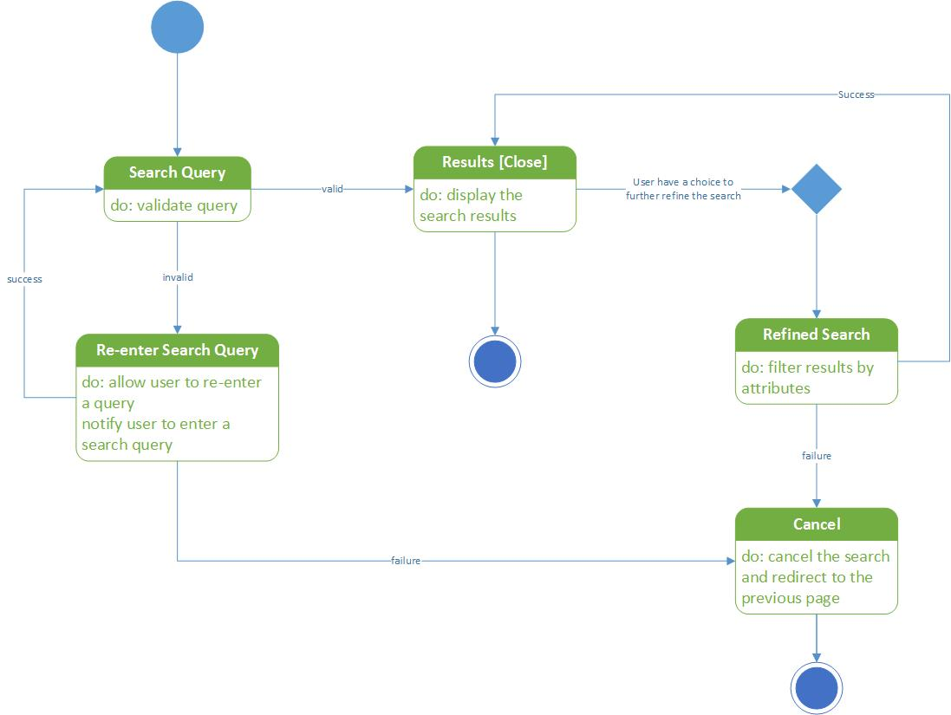

State Transition Diagram: Registration

State Transition Diagram: Login

State Transition Diagram: Payment

UML Class Diagram: Category

State Transition Diagram: Review a Tutor



State Transition Diagram: Map



State Transition Diagram: Communication



State Transition Diagram: Advertisement

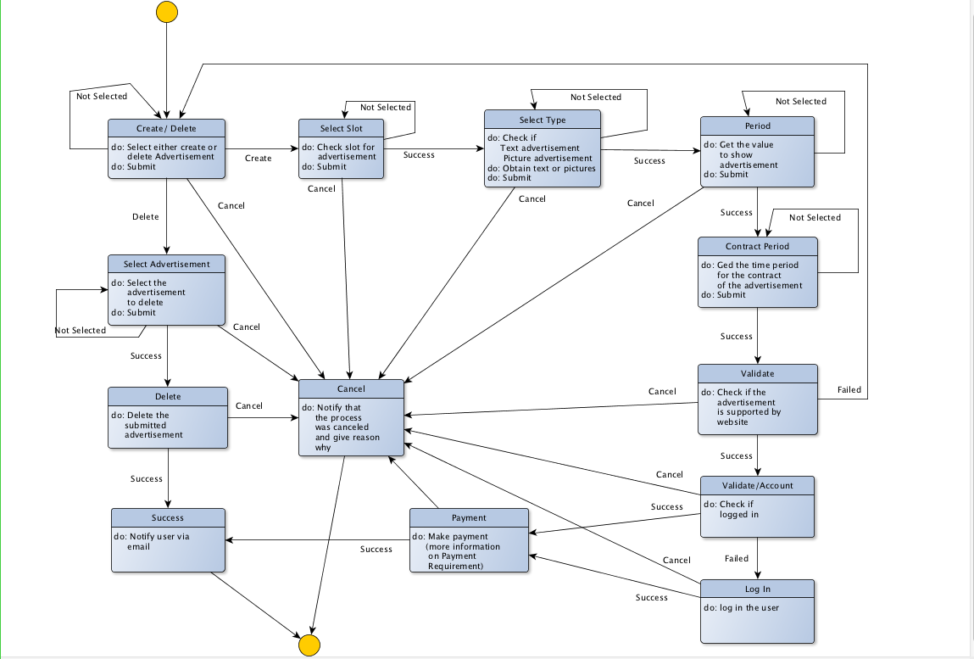

## 5.3 Conceptual Data Model - Database

­

## 5.4 Screenshots

* All the foreign keys without a primary key have a unique key assigned and the connectors don’t reflect the actual relationships.
* The following images are preliminary and partial-design sketches, and will be subjected to change.

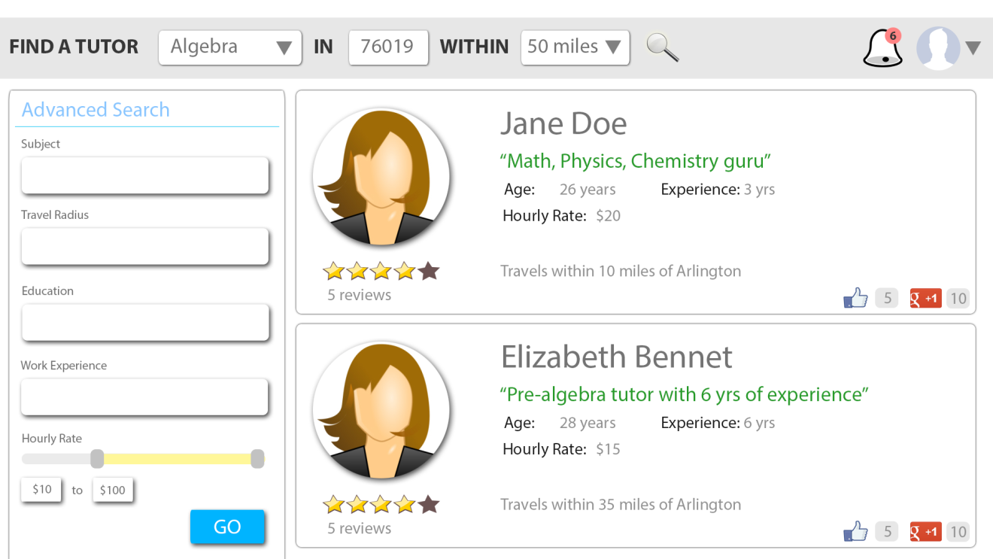

## tutorProfile5.5 Test Plan

Test plan will be provided later.

# 6. Assumptions and Constraints

## 6.1 ASSUMPTIONS

The following is a list of assumptions:

* Only people who are 18 and older can order.
* Any 16-digit credit card number is assumed to be a valid card.
* Tutors have a high school degree or an equivalent at a minimum
* Tutors are older than 18 years
* Users already have a working email accounts

## 6.2 CONSTRAINTS

The following is a list of constraints:

* Team lacks web development skills
* Team lacks knowledge in database system
* Not all the members are always available to meet at a specific time
* Not all the members are familiar with either Mac OS or Windows
* The website has to be responsive on PCs, smartphones, and tablet PCs
* Server is not guaranteed to have a 100% uptime

## 6.3 Out of Scope material

The following is a list of “out of scope” material:

* Post Project maintenance is not covered
* Backend interface for updating the website is not implemented
* Copyrighting the source code is not covered
* Consideration for exceptionally high traffic into the website is not considered
* Server maintenance is not considered

# 7. Delivery and Schedule

|  |  |  |  |  |
| --- | --- | --- | --- | --- |
| Task/Milestone Description | Anticipated Start Date | Anticipated End Date | Status | Comments |
| Prepare Requirements and UML diagram | 9-10-2013 | 10-10-2013 | Completed | Completed all the UMLs and requirements. |
| SRA document (Includes project objectives, Requirements and UML diagrams) | 9-15-2013 | 10-17-2013 | Completed | Deliverable will be the SRA document. All stakeholders agree on the content of the SRA by signing in section 8. |
| Presentation of SRA | 10-11-13 | 10-15-2013 | Completed | Presentation was made by Santosh and Roshan. |
| Creating the template (Photoshop design) | 10-10-2013 | 10-15-2013 | Completed | All template design completed |
| Web page design and Navigation (converting to HTML) | 10-12-2013 | 10-21-2013 | Completed | All web page design completed |
| Database Design | 10-21-2013 | 10-21-2013 | Completed | All databases table design completed |
| Designing the web app (PHP Script) | 10-22-2013 | 11-28-2013 | Completed | Web app creation completed |
| Test Data Entry | 11-28-2013 | 11-29-2013 |  | Not Applicable |
| Test Plan Delivery | 11-28-2013 | 12-01-2013 |  | Not Applicable |
| External Documentation (i.e. User Manual) | 11-28-2013 | 12-03-2013 | Completed | User manual created |
| Final Milestone: project delivery | 11-30-2013 | 12-5-2013 | Completed | Delivered all the project materials including documentation |

# 8. Stakeholder Approval Form

|  |  |  |  |
| --- | --- | --- | --- |
| Stakeholder Name | Stakeholder Role | Stakeholder Comments | Stakeholder Approval Signature and Date |
| Bahram Khalili | Development Mgr |  |  |
| Hafiz Fahad | Project Assistant |  |  |
| Dineth Hettiarachchi | Developer |  |  |
| Samir Shrestha | Developer |  |  |
| Roshan Lamichhane | Developer |  |  |
| Santosh Shrestha | Developer |  |  |

# Appendix:

None